QalaBazaar: Agile Project Management, Requirements, Design, and Testing Report

Bandana Pandey and Sandhya Dahal
Model Institute of Technology
CSE 220 Principles of Software Engineering
Professor Poshan Karki
August 19, 2026

Contents
Introduction 1
Scope 1
Team Roles 1
Agile Process Used 1
Project Management 1
Product Backlog 1
Sprint 1 Planning 1
Gantt Chart 1
Trello Board Activity 1
Requirement Documents 1
Organization Profile 1
Requirement-Gathering Techniques 1
Current vs Proposed Management System 1
Functional Requirements 1
Non-Functional Requirements 1
Stakeholder Analysis 1
UML Diagrams 1
Use Case Diagram 1
Sequence Diagram 1
Class Diagram 1
Activity Diagram 1
GitHub Repository Structure 1
Commit History 1
Branching and Pull Requests 1
Test Cases 1
Reflections on Using Agile Tools 1
Conclusion 1

QalaBazaar: Agile Project Management, Requirements, Design, and Testing Report

Introduction

This report documents the entire project management, requirement analysis, system design and testing process for an e-commerce site called QalaBazaar, which was developed as a team project simulating real-world Agile software development principles. This project doesn't implement the system as code, but rather as plans, documentation, and design prior to development, with Trello being the Agile project management tool, and GitHub the version controlled document management tool (Schwaber & Sutherland, 2020).

QalaBazaar also attempts to solve a real issue that local Nepali artisans are currently suffering from: They are selling hand-made products via social media and informal markets, making it difficult for them to handle products, order and payments efficiently (Hendricks & Mwapwele, 2023). The platform would enable sellers to have a control over their products and orders and customers would be able to find, buy, pay for, and monitor handmade products online.

This report shows the entire Agile simulated project life cycle from Sprint planning and backlog management, to requirement gathering, stakeholder analysis, as well as system design in UML diagrams, and finally the development of test cases from several layers of testing. It ends with a description of the repository structure used on GitHub for version control of this project and a lesson learned from using Agile tools within a documentation

Project Scope
This project tackles the planning, requirement analysis and system design of e-commerce platform “QalaBazaar”. Does not cover coding, implementation or deployment of the system. The proposed platform will have the following functions:Customer and Seller Registration
- Product Listing and Inventory Management
- Order Management
- Payment Processing
- Delivery Tracking
- Search and Information Retrieval
- User Access and Security
- Admin Monitoring and Seller Approval

All the deliverables created in this scope are: Agile project plan on Trello, GitHub repository with all requirements and design documentation, four UML diagrams (Use Case, Class, Sequence, Activity) and structured set of test cases (Unit, Integration, System, User Acceptance Testing).

Team Roles
This project was carried out in collaboration with a 2 person project team. Considering the rather limited size of the team, each team member assumed responsibility for a group of deliverables while working together on the planning and review activities, as is common in small Agile teams.
Team member | Primary Role | Key Responsibilities
Bandana Pandey | Product owner/ Design Lead | Prioritized and maintained the product backlog and user stories; created all UML diagram (use case, class sequence, Activity); coordinated system level testing.
Sandhya Dahal | Scrum Master/ Business Analyst | Set up and administered the Trello board and GitHub repository; led requirement gathering (questionnaires, direct observation brainstorming); authored the function and stakeholder requirement documentation and stakeholder analysis; facilitated sprint planning and sprint review designed unit level and integration test cases.

Agile Process Used
This project was done using a Scrum Development Methodology with an Agile approach for a 2-person team to create a documentation-based simulation of real-world software development. The iterative delivery, ongoing stakeholder participation, and flexible planning of agile development are contrasted to a rigid up-front specification (Schwaber & Sutherland, 2020). The team used these principles in the following way:
Prior to any work being done, all user stories were recorded and prioritized in a Trello Product Backlog list (see Project Management section).
- Sprint structure: Sprint 1 was a two-week iteration (August 18 - 29, 2026) where the team planned and executed the deliverables related to the requirement analysis and design work documented in this report.
- Kanban board: The Trello board was set up as a Kanban board with six lists (Product Backlog, Sprint 1 Backlog, To Do, In Progress, In Review and Done) and each task was added as a card with an assigned member, due date, priority label and checklist.
- Definition of Done: a card can only be moved to Done when its deliverable has been uploaded to GitHub, with a clear commit message, reviewed by the other team member, and (where applicable) documented with a screenshot.
- Stand-up/review: brief, regular check-in between the two members were like mini stand-ups and the end of the Sprint involved a review of artifacts that were completed and a brief retrospective.

Project Management

Product Backlog
The 10 user stories are written for the three main actors (Customer, Seller, Admin) and given a priority and a story point estimate on a Fibonacci-like scale.

ID | User story | Priority | point | status
US-01 | As a Seller, I want to register on QalaBazaar and create a shop profile with business information so that I can list my products on QalaBazaar | High | 3 | Backlog
US-02 | As a Customer, I want to register/log in using email or phone, so that I can securely access my account. | High | 3 | Backlog
US-03 | As a Seller, I want to add, edit and remove products in order to manage my inventory online. | High | 5 | Backlog
US-04 | As a Customer, I want to be able to browse the products and search using category, price or artisan region, so that I may more easily find handmade products. | High | 5 | Backlog
US-05 | As a Customer, I want to add products to a shopping cart and check out, so that I can purchase multiple items at once. | High | 8 | Backlog
US-06 | As a Customer, I want to pay online through eSewa/Khalti or Cash on Delivery payment so that I can make secure purchases. | High | 8 | Backlog
US-07 | As a Customer, I would like to be able to trace the progress of my order, so that I can be sure when to expect my order. | Medium | 5 | Backlog
US-08 | As a Seller, I want to be able to see and control my incoming orders, so I can have them completed in a timely manner. | High | 5 | Backlog
US-09 | As a Customer, I want to rate and review products I have purchased that I like, so that I can provide feedback to the community | Medium | 3 | Backlog
US-10 | As an Admin, I want to approve new seller registrations and monitor listings, so that product quality and authenticity are maintained. | Medium | 5 | Backlog

Sprint 1 Planning
Sprint 1 (August 17–20, 2026) focused on requirement analysis, stakeholder analysis, UML diagram design, test case design, and GitHub/Trello setup — the artifacts needed to support user stories US-01 through US-06. The table below reflects the completed sprint.
Task | Assigned To | Points | Priority | Deadline | Status
Set up Trello board (lists, labels, backlog cards) | Sandhya Dahal | 2 | High | Aug 18 | Done
Set up GitHub repository & folder structure | Both | 2 | High | Aug 19 | Done
Draft functional requirements document | Sandhya Dahal | 5 | High | Aug 20 | Done
Draft non-functional requirements document | Sandhya Dahal | 3 | High | Aug 21 | Done
Conduct stakeholder analysis | Bandana Pandey | 3 | High | Aug 21 | Done
Create Use Case Diagram | Bandana Pandey | 5 | High | Aug 23 | Done
Create Class Diagram | Bandana Pandey | 5 | High | Aug 25 | Done
Create Sequence & Activity Diagrams | Bandana Pandey | 5 | High | Aug 26 | Done
Design test cases (Unit/Integration/System/UAT) | Both | 5 | Medium | Aug 28 | Done
Create branch, commit docs, open & merge pull request | Sandhya Dahal | 2 | High | Aug 28 | Done
Sprint review, board screenshot, retrospective notes | Both | 1 | High | Aug 29 | Done

Gantt Chart
The Gantt chart below was created with an external charting application and represents the Sprint 1 schedule listed above in the task table.
Figure 1
Sprint 1 Gantt chart (August 17–29, 2026)
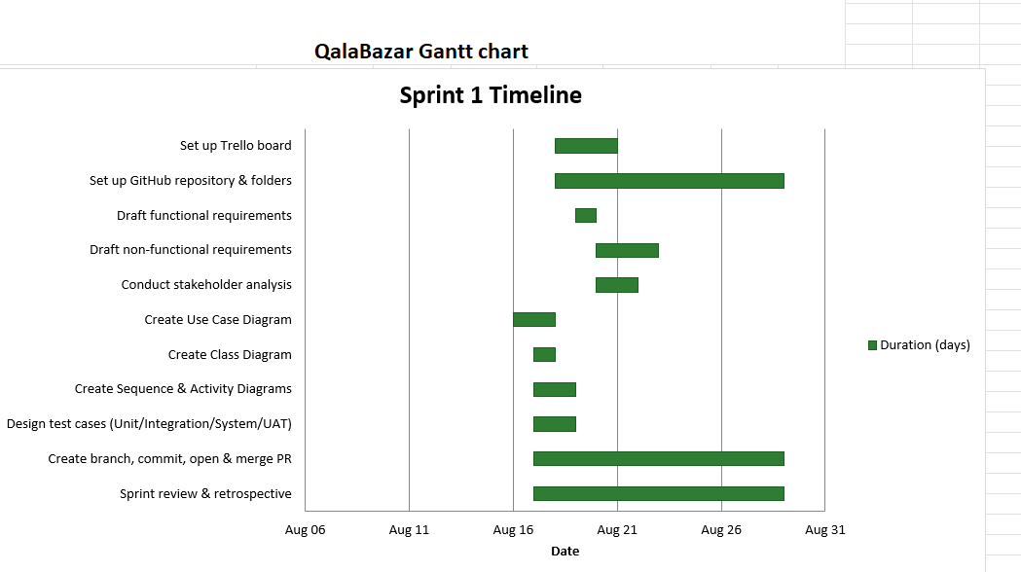

Trello Board Activity
The Trello board named QalaBazzar -Product Backlog” was maintained and was moved between Product Backlog, In Review, and Done for the duration of the work on cards. As of the time of writing, a feature board will contain all 10 user stories (US-01 through US-10), as well as several setup and requirements tasks that are complete, such as ‘Set up Trello Board’ and ‘Create GitHub repo + folder structure,' both of which have a red High-priority label and a due date, and both include a checklist of items. The In Review list would include ‘Draft non-functional requirements document’ and ‘Conduct stakeholder analysis,' with initial drafts attached to each of them; the former has a due date and red High-priority label while the latter has a due date and a checklist with two user stories attached. Card labels, which are set up during the board setup, are a combination of markers: red marker – High priority, light blue marker – Documentation-type
Figure 2
QalaBazaar Trello board -Product Backlog, In Review, and Done lists
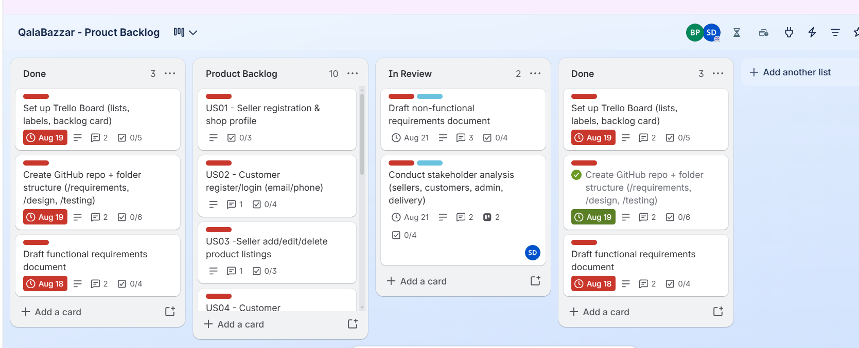
Requirement Documents
The requirements engineering process defines requirements for a software system based on the needs of the software user and the software stakeholders and uses a lifecycle that is multifaceted and iterative (Sadiq & Jain, 2012). This section includes an organization profile, requirement-gathering techniques utilized during development, comparison of the current and proposed system and the functional and non-functional requirements, stakeholder mapping and analyses that will be undertaken are summarized and presented.

Organization Profile
Organization Name | QalaBazaar
Organization Type | E-commerce marketplace for handmade and artisan products
Location | Kathmandu, Nepal (operating online, nationwide)
Main Service | A website that is an e-commerce platform for local artisans to showcase their products and reach customers to buy the items, making them available for ordering, tracking payments and delivery.
Key Stakeholders | Users, vendors/artisans, admin of the platform, payment gateway companies, and partners for delivery.
Main Operational Activities | Customer account set-up and management, product registration and inventory, order processing, payment processing, delivery co-ordination and customer support.
Requirement Gathering
Requirement elicitation is one of the most important steps in the software development process. It involves understanding what users and stakeholders need from a system before it is built. Traditionally, this has been done using methods such as interviews, questionnaires, document reviews, and direct observation (Akhtar & Akhtar, 2025). For the QalaBazaar case study, questionnaires, direct observation, and brainstorming were used to understand the existing manual and social-media-based selling process and to identify the requirements of the proposed computer-based marketplace. These are the methods used to gather information:

Questionnaires
A questionnaire was developed using Google Forms to collect structured information from relevant stakeholders of QalaBazaar, including prospective customers and artisan sellers. The questionnaire focused on understanding current buying and selling methods, problems faced by users, expected payment options, and features expected from a proposed computer-based marketplace. The questionnaire included questions related to current selling channels, common challenges, payment preferences, expected features, and general feedback.
The questionnaire can be accessed through the following link.
QalaBazaar Requirement Gathering Questionnaire

Direct Observation
Direct observation is another technique used to gather information, in order to understand the actual workflow currently used by local artisans to sell their products. Through observation, the daily activities and processes performed by sellers and customers can be examined directly rather than relying only on information provided through questionnaires. During the observation, particular attention was given to:
- Product listing and communication with customers through social media.
- Manual price negotiation between sellers and customers.
- Payment collection methods, such as cash or bank transfer.
- Packing and arranging delivery through local couriers.
- Problems such as delays, miscommunication, or difficulty tracking orders.
Direct observation helped identify the actual problems and inefficiencies within the current manual system. The information gathered was compared with the results from the questionnaire and other requirement-gathering techniques. This helped ensure that the requirements of the proposed computer-based marketplace are based on artisans' real operational needs.
Brainstorming
During the brainstorming session, stakeholders shared their opinions, experiences, problems, and suggestions related to the current selling process. The ideas generated during the session were later reviewed and organized according to their importance and relevance to the proposed system. The main ideas discussed during the brainstorming session included:
- Centralizing product listings and inventory management.
- Providing secure and transparent digital payment options.
- Real-time order and delivery tracking.
- Seller verification and quality assurance.
- Reducing manual negotiation and communication delays.
- AI-powered product recommendations and customer support.
The brainstorming activity helped identify additional requirements that may not have been discovered through questionnaires and observation alone.

Current vs Proposed Management System
Current Management System | Proposed Management System
Customers discover products through informal social media posts. | Customers can browse and search products directly on the QalaBazaar platform.
Sellers manually check physical stock availability. | The system checks real-time inventory availability automatically.
The prices are negotiated manually by sellers and buyers using chat messages. | Product prices are clearly and uniformly displayed on the platform.
Customers pay by cash or bank transfer and no proof of transaction is provided. | Customers make safe online payments or cash-on-delivery payments.
Sellers manually pack orders and arrange orders to be delivered by local couriers. | Sellers are automatically informed and control shipping via the system.
Customers have no way to track their order status. | Customers can track their order status in real time through the platform.

Current vs Proposed system
Figure 3
Current vs proposed Qalabazar process flow for product discovery stock checking and payment.
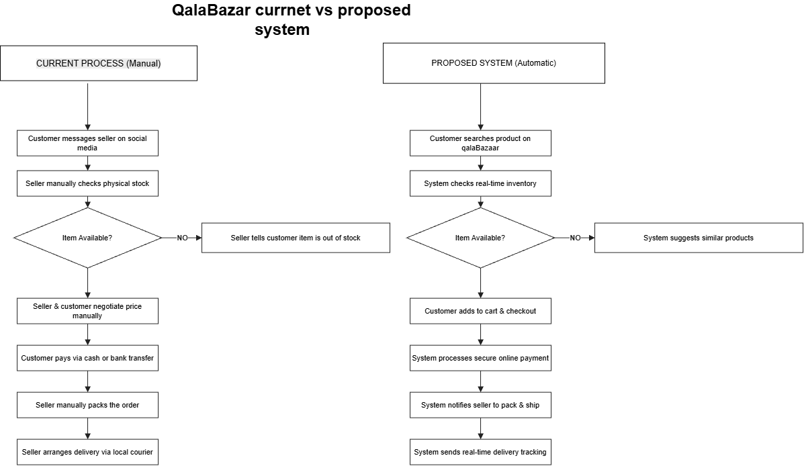
Apart from the four major UML diagrams, a current versus proposed process flowchart was developed which visually compares the currently available social media-based selling process with the proposed QalaBazaar process. The next step in the current process is a direct message from a customer to a seller on a social media platform, then the seller manually checks the physical inventory and if the product is not in stock, the seller tells the customer it is out of stock with no alternative available. In the case of a listed price, it is negotiated by hand, no proof of payment is needed; in the case of a bank transfer, it is no different, and in the case of packing the product and arranging delivery, it is done manually by a local courier.
On the proposed-system side, the same decision point is also done automatically: when proposed systems check against real-time inventory (supporting FR4), if the item is not available, it will automatically suggest another related item instead of stopping the conversation. If available, the customer places the item into their shopping cart, then is securely led through a digital gateway to pay for the item (FR6), the seller is automatically notified to pack and ship the order, and the customer is automatically notified of the progress of the order to the point where it is shipped (FR7).
This diagram is complementary to the above UML diagrams, as it explicitly identifies the reasons for prioritising the requirements in the table above: each manual bottleneck (on the left) has a system-supported, automated counterpart (on the right), justifying the high priority assigned to them in the table (High).

Functional Requirement
Functional requirements are the core components of a software system that specify the particular functionalities that the product must offer. Functional requirements dictate the behavior of the software and are the basic ingredients of software development as well as defining the software structure (Kung, 2024).
This section describes the main functions that QalaBazzar is expected to provide. The requirements explain what the system should do from a functional point of view.
Table 1:
Functional Requirement Table
Requirement ID | Functional Requirement | Priority
FR1 | The system shall allow customers and sellers to register and create accounts | High
FR2 | The system shall allow sellers to add, edit and remove product listing, price, description and image | High
FR3 | The system shall allow customers search and browse products by price, category and region | High
FR4 | The system shall display real-time product availability to customers | High
FR5 | The system shall allow customers to add products to cart and checkout completely | High
FR6 | The system shall process secure online transactions through a supported payment gateways | High
FR7 |  | Medium
FR8 | The system shall allow sellers to view and manage incoming orders | High
FR9 | The system shall allow customers to rate and review purchased products | Medium
FR10 | The system shall allow admin to approve seller registrations and monitor product listings | Medium
FR11 | The system shall allow authorized users to securely log in and log out of the system | High

Note: This table depicts the functions and services which the proposed QalaBazaar platform is supposed to provide, including their priority
Non-functional Requirement
Non-functional requirements (NFRs) refers to the emergent qualities of a software system instead of its specific functionality. They define how the system should behave under certain condition. For example: Limitation imposed by user environment or platform’s operating context (Kung, 2024).
Table 2:
Non-functional Requirement
Requirement Id | Non-Functional Requirement | Priority
NFR1 | The system shall protect user data and payment information through secure login, encryption and access control | High
NFR2 | The system shall respond to user request within a reasonable time | High
NRF3 | The system shall be easy for customers and sellers with limited technical fault | High
NFR4 | The system shall be available and accessible to customers and sellers to all times | Medium
NFR5 | The system shall be maintained frequently with added features like AI and updates | High
NFR6 | The system shall be compatible with commonly used web browsers and mobile devices. | Medium
NFR8 | The system shall scale to accommodate a growing number of seller, customer and products | Medium

Note: Table 2 shows the NFRs of the proposed QalaBazaar platform including their priority.

Stakeholder Analysis

Stakeholder analysis is used to determine who the stakeholders are who impact or are impacted by the QalaBazaar platform as well as to measure their power (or level of influence) and interest (or need) in the project's outcome. This analysis serves as a foundation for how the project team interacts with each group of stakeholders during the gathering of requirements, the design, and future development stages of the project.
Table 3
Stakeholder analaysis
Stakeholder | Category | Role in the Project | Interest/ expectations | Power | Interest | Engagement strategy
Customer | External | Browser, purchase, pay for, and review handmade products | Variety and secure transaction, reliable delivery, fair prices. | High | High | Feedback surveys, support, loyalty and review capabilities.
Seller/ Artisans | External | Register a shop, list product, manage inventory and incoming orders. | Larger market exposure, fair commission charges, sellers simple tools, swift payouts. | High | High | Onboarding support and training from seller, regular communication about policy changes from seller.
Platform Admin | Internal | Approve seller registrations monitor listings enforce platform policies. | Platform security, minimized fraud and dispute issues, everyday hassle-free operations. | High | High | Firsthand experience with system design, moderation tools and policy decisions.
Development Team (Bandana and Sandhya) | External | Process online transaction initiated through the platform | Academic, Agile, technical and successful Delivery | High | High | Frequent requirement discussions, review of sprints, design iteration.
Payment gateway provider (Esewa, Khalti) | External | Process online transaction initiated through the platform. | The number of transactions, standards of integration, successful settling. | High | Medium | Keep API integrations up-to date, track uptime and service-level arrangements.
Regulatory bodies (Eg Nepal Rasta bank, Dept. of commerce) | External | Set legal and compliance requirement for digital payments and ecommerce. | Compliance with regulations, customer protection, data security. | High | Low | Maintain a platform that comply with relevant digital payment and consumer-protection laws.
Academic evaluator instructor (Professor Poshan Karki) | Internal Academic | Evaluate the projects requirements analysis and deliverables | Use of Quality of requirement analysis, Agile methodology and Software engineering principles. | Low | High | Deliverables, sprint boards and progress reports are routinely submitted.
Delivery/ courier partners | External | Handle physical pickup and delivery of customer orders. | Accurate order volume, pickup and delivery details. | Medium | Medium | Set up integration to delivery status and service level agreements.
Local artisans community/ associations | External | Represent the broader interest of local artisans and craft groups | Better awareness and visibility of local handmade crafts, couple with better market access. | Low | Medium | Periodic updates and potential future outreach/partnership activities.
Genral public/ social media audience | External | Potential future customers or sellers who discover QalaBazar online. | Knowledge and familiarity with the website and its services. | Low | Low | Continued marketing and social media outreach.

Figure 2
QalaBazaar stakeholder power-interest grid
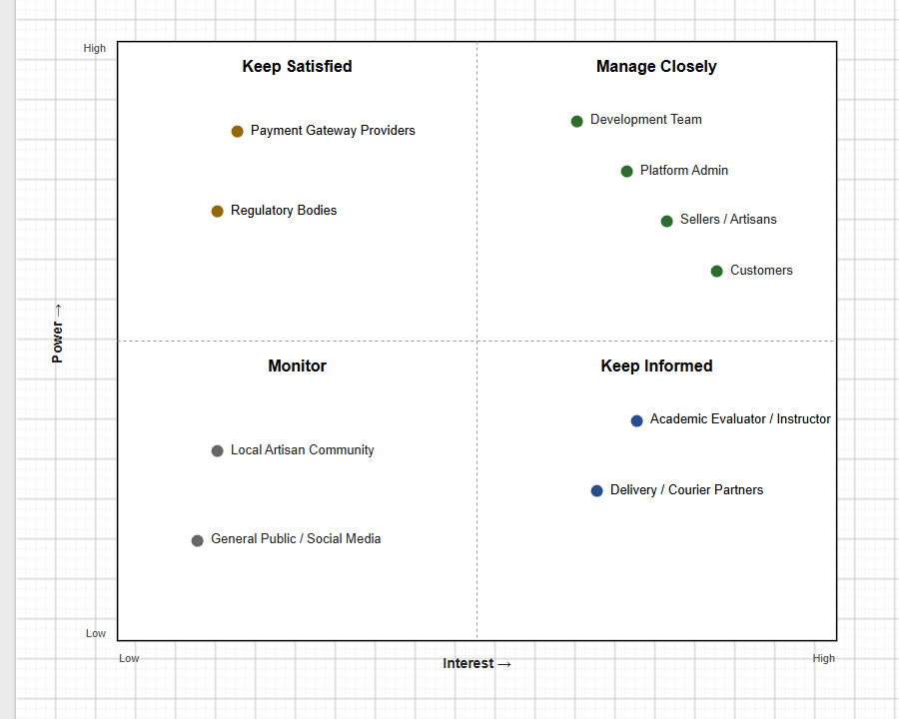
UML Diagrams

A set of four complementary UML diagrams were created to link with the above business requirements to a technical system design (Usecase Diagram, Sequence Diagram, Class Diagram, Activity Diagram). They represent the architecture of the proposed system, according to its structure, behavior and interactions and are a bridge between Business Requirements and Technical Design (Kung, 2024).

Use Case Diagram
Figure 3
Actors and their use of QalaBazaar system use cases in the context of actors (Customer, Seller, Admin, Payment Gateway, Delivery Partner)
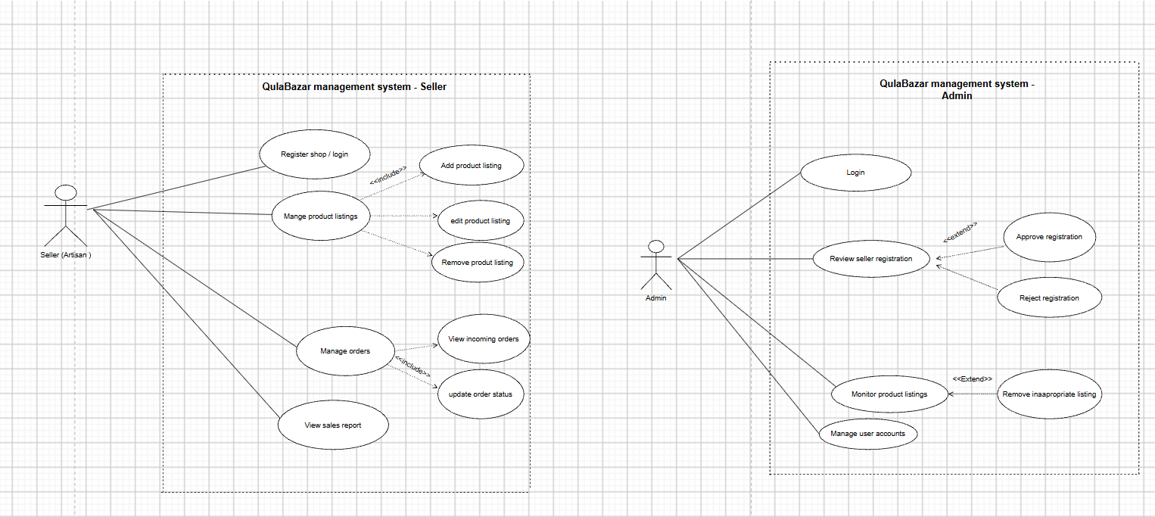
Figure 4
Use case for delivery partner and payment gateway
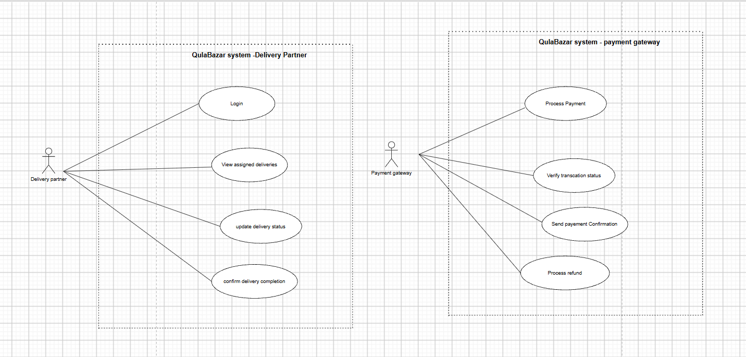
Figure 5
Use case for customer
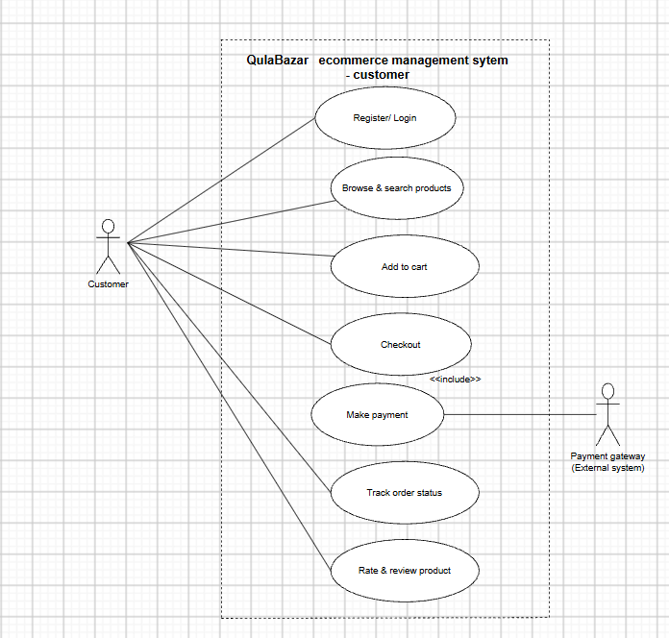

The Use Case Diagram depicts all functional interactions among the different external actors and the QalaBazaar system, giving an overview from the end user's point of view. The Customer actor registers, browses and searches products, adds to cart, checks out, pays, tracks orders and rates/reviews purchased products. Seller actor enrolls a shop, manages product listings and deals with and delivers orders from customers. It is the responsibility of the Admin actor to approve seller registrations and to track product listings. The Payment Gateway and Delivery Partner are secondary entities outside of the application, that support the checkout and the tracking use case respectively. This diagram illustrates how each requirement is mapped to a respective use case: FR5 and FR6 are represented by the use cases 'Checkout' and 'Make Payment' respectively, with the latter use case <<include>>'ed' by the former, as making payment is required for each checkout requirement.

Sequence Diagram
Figure 6
Message flow between Customer, QalaBazaar System, Payment Gateway, and Order Database during checkout and payment
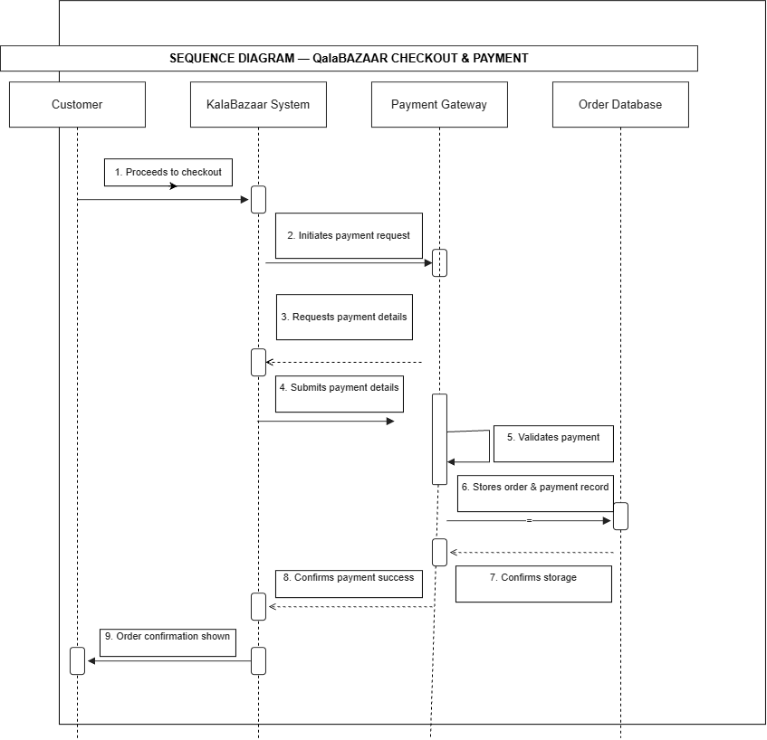
The Sequence Diagram highlights the detail of interaction and message flow in one of the most critical processes within the marketplace: Checkout and payment (supporting FR5, FR6, NFR1, NFR2). It illustrates the path taken by the customer to check out, the system asking for and validating payment via the payment gateway, and then the system storing the confirmed order in the Order Database, and then sending back the order confirmation messages, etc. at each step. This diagram is useful for developers to ensure that validation, error handling, and secure data storage are taken care of before beginning development..

Class Diagram
Figure 7
Class structure showing User as parent of Customer, Seller, and Admin, and relationships to Product and Order
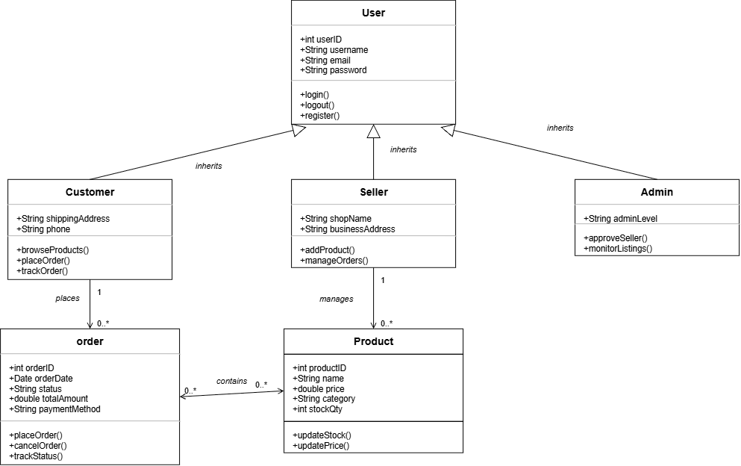

The Class Diagram shows the static structure of the QalaBazaar platform: User is a base class that includes the shared login/logout functionality for all classes, and has three subclasses: Customer, Seller and Admin, each with its own set of attributes and methods; Seller has a subclass of Product which can be managed; Customer places an Order which contains a set of Products. This diagram directly relates to the functional requirements, such as FR2 (product listings) to the Seller-Product relationship, FR5-FR6 (checkout and payment) to the Order class and FR11 (secure login) to the shared User inheritance structure, and contains the blueprint for the eventual database schema.

Activity Diagram
Figure 8
Workflow for checkout and payment, including the payment-success decision and retry path
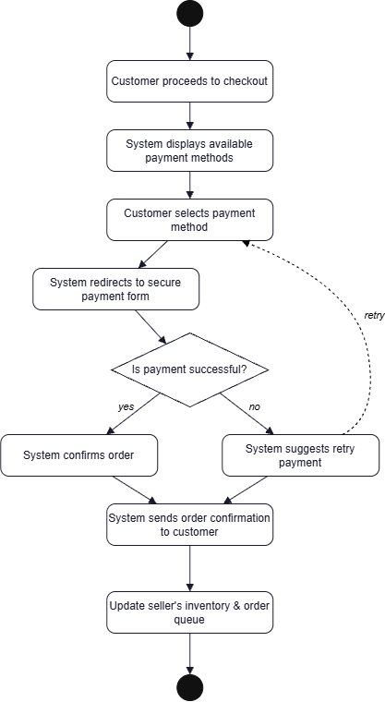
The checkout and payment process is represented by the Activity Diagram which is closely related to FR5 and FR6, and reflects the dynamic flow of the process (Seidl et al., 2015). It demonstrates sequential activities from checkout initiation up to the point that the payment method is chosen, a dashed service line indicates the transition to the back end inventory update, and there is an obvious start/end point where a decision is made for the payment to be successful, or a retry path is followed if it fails. This diagram is helpful for NFR3 (usability), as the workflow reflects customer expectations; and also for NFR2 (performance), because it presents a clear route for retries, avoiding delay.
GitHub Repository Structure
All requirement, design, and testing artifacts produced for QalaBazaar are version-controlled in a GitHub repository, organized into clearly separated folders so that any reviewer can quickly locate a given deliverable.
Figure 7
GitHub repository structure
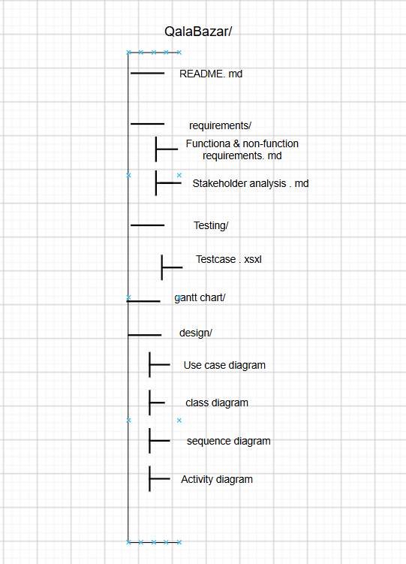

Commit History
Each commit uses a short, descriptive message summarizing the change, following the same pattern used throughout the project:
Table 4
Commit history GitHub
S.N | Commit Message
1 | Initial commit: add repository structure and README
2 | Add functional and non-functional requirements document
3 | Add stakeholder analysis document
4 | Add Use Case diagram for Customer, Seller, and Admin actors
5 | Add Class diagram showing User inheritance structure
6 | Add Sequence diagram for checkout and payment flow
7 | Add Activity diagram for checkout workflow
8 | Add Unit and Integration test cases
9 | Add System and User Acceptance test cases with summary charts
10 | Merge feature/uml-diagrams into main
11 | Add test case and merge it into main

Branching and Pull Requests
A feature branch was created off main, feature/uml-diagrams, to work on and discuss the four UML diagrams separately from the requirements and testing work. Afterwards, a pull request was opened to sum up the changes made in the diagrams, and the second team member checked the diagrams against the functional requirements and approved them. The branch was then merged into main, resulting in a repository with a pristine history that shows the branch-review-merge process that one would expect of a real software team.

Test Cases
A well-defined set of 34 test cases were developed and maintained in the GitHub repository in an Excel workbook, QalaBazaar_Test_Cases.xlsx, with each test case having four testing levels: Unit, Integration, System and User Acceptance Testing (UAT). All test cases contain the following information: test objective, preconditions, test input, test steps, expected output, actual output, Pass/Fail/Fail (Minor) status, Tester, and Date tested. The Pass/Fail/Fail (Minor) status is color coded by conditional formatting.
Table
Test Level | Total | Pass | Fail | Pass Rate
Unit | 10 | 8 | 2 | 80.0%
Integration | 8 | 7 | 1 | 87.5%
System | 8 | 7 | 1 | 87.5%
UAT | 8 | 7 | 1 | 87.5%
Total | 34 | 29 | 5 | 85.3%

Figure 8
Test case of unit testing
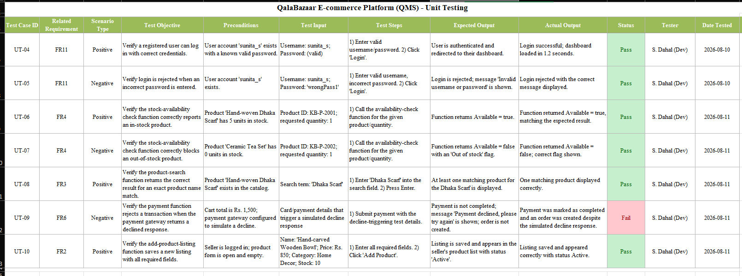
Figure 9
Test cases summary table and graph
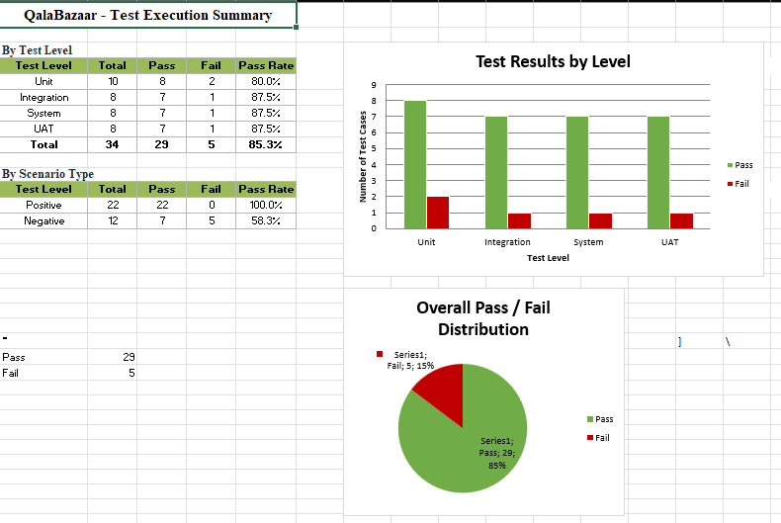

All summary tables are dynamically generated from the live formulas in the workbook, so that the summary is automatically recalculated if any of the test values are changed, and they include a clustered bar chart of the Pass/Fail counts by test level, a pie chart of the overall Pass/Fail distribution, and a Gantt-style chart of the test execution timeline. All 5 failed cases were in negative (edge-case) test scenarios, whereas all 22 positive-scenario test cases passed, meaning that core happy-path functionality worked as expected and a few edge-case handling gaps were discovered during development (such as weak-password validation, empty-cart checkout blocking)

Reflections on Using Agile Tools

We couldn't have brought two tools together that were used by real software teams every day without writing any code than we did with Trello and GitHub in this documentation-centric Agile simulation.We were able to get hands-on experience with two tools that are used by real software teams on a daily basis without writing any code, and we couldn't have done that without Trello and GitHub combined in a documentation-focused Agile simulation. The visual board on Trello showed at a glance who had the task and how it was doing, with cards moving from To Do to In Progress to Done, giving a sense of progress that would not have been conveyed in a 'To Do' list; and the labelling system and due dates made it easy to see what items were urgent and might be missed.

Meanwhile, GitHub emphasized the utility of version control even for non-code artifacts: With each requirements document, diagram and test case being version-controlled with a commit history, we were able to see how the project developed and easily roll back or compare versions if changes became necessary. The branch-and-pull-request process although usually more associated with code review was a nice light-weight peer review check point for our UML diagrams prior to incorporating them into the main deliverable set.

The biggest hurdle was designing regular Scrum ceremonies that were used to a larger team of people, creating working software increments, to the two-person team creating documentation. Sprint planning now was reframed around documenting and designing milestones instead of features that could be shipped and daily stand ups were shortened to being brief informal meetings. Having to repeat this project, we would start our Definition of Done even more precisely, because although it's easy to leave the documentation deliverables more of a "squeaky spot" than code, it doesn't compile or fail.

Conclusion
This report has demonstrated a small group of Agile team members how to get a software project from stakeholder requirements gathering to a complete, testable, and well-defined system design using industry standard project management and version control tools, Trello and GitHub respectively. The product backlog and Sprint 1 plan illustrate how the Agile approach to project management is applied; the requirements documentation and stakeholder analysis illustrate rigorous requirement engineering; there are four UML diagrams that illustrate the translation of business requirements into technical design; and the 34-case test suite illustrates that quality assurance can and should be planned before implementation begins. All these artifacts provide a solid and complete base to the future development team of QalaBazaar.
References
Abisuga-Oyekunle, O. A., & Fillis, I. R. (2017). The role of handicraft micro-enterprises as a catalyst for youth employment. Creative Industries Journal, 10(1), 59–74. https://doi.org/10.1080/17510694.2016.1247628
Akhtar, A., & Akhtar, S. (2025). Requirements elicitation in transition: A review of conventional and contemporary approaches. Journal of Software Engineering, 1(1), 32. https://doi.org/10.62762/jse.2025.862549
Ali, A., Khalil, I., Ahmad, I., Parveen, I., & Zaman, U. K. uz. (2022). Role of non-functional requirements in projects' success (pp. 1–7). https://doi.org/10.1109/ICoDT255437.2022.9787463
Hendricks, S., & Mwapwele, S. D. (2023). A systematic literature review on the factors influencing e-commerce adoption in developing countries. Data and Information Management, 8(1), Article 100045. https://doi.org/10.1016/j.dim.2023.100045
Kung, D. C. (2024). Software engineering (2nd ed.). McGraw Hill LLC.
Sadiq, M., & Jain, S. K. (2012). An insight into requirements engineering processes (pp. 313–318). Springer. https://doi.org/10.1007/978-3-642-35615-5_48
Schwaber, K., & Sutherland, J. (2020). The Scrum guide: The definitive guide to Scrum: The rules of the game. https://scrumguides.org/scrum-guide.html
Seidl, M., Scholz, M., Huemer, C., & Kappel, G. (2015). The activity diagram. In UML @ classroom. Undergraduate Topics in Computer Science. Springer, Cham. https://doi.org/10.1007/978-3-319-12742-2_7

